How I made the circuit in Proteus
1. I went to the ‘Component mode’ tab and the P checkbox/icon and then searched the resistor and placed it in the sheet

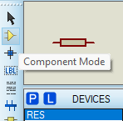
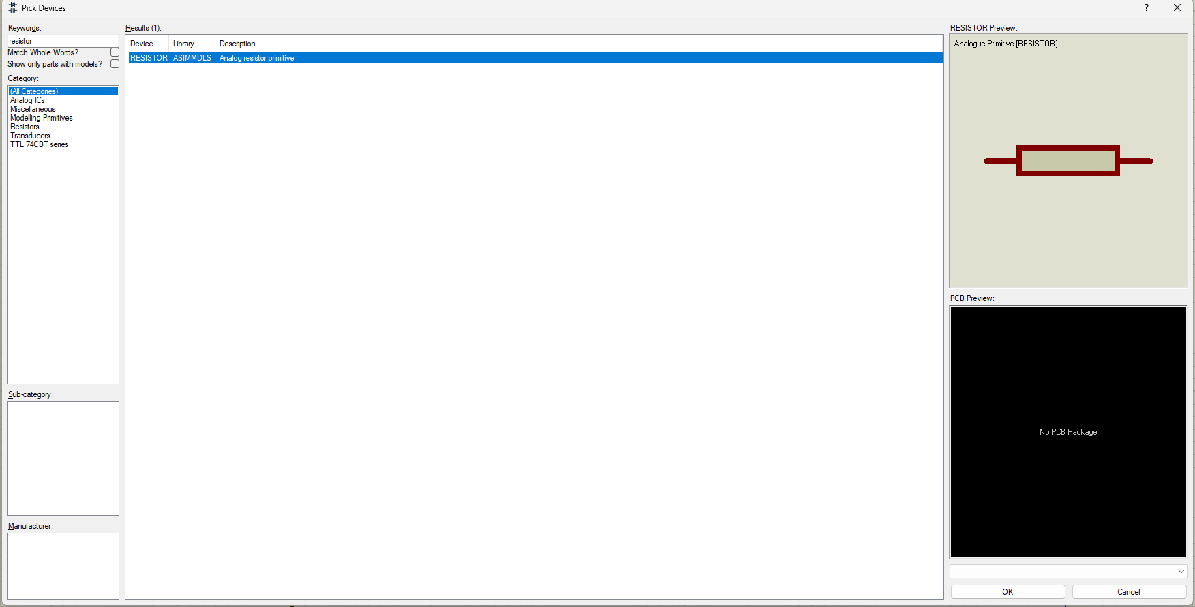
2. Then I went to ‘Instrument’ tab and drop the signal generator and the oscilloscope in the sheet.
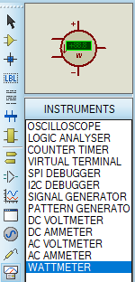
3. I then connected the two resistors in the series by drawing a wire with mouse and changed the value of their resistances R1 =5.1 ohm and R2 = 3.3 ohm
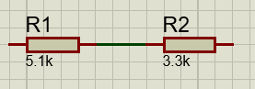
4. Then I connected the positive terminal of the signal generator to R1 and grounded the negative terminal by dropping the ground from ‘Subcircuit Mode’ and also connected R2 to the ground.
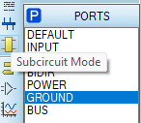
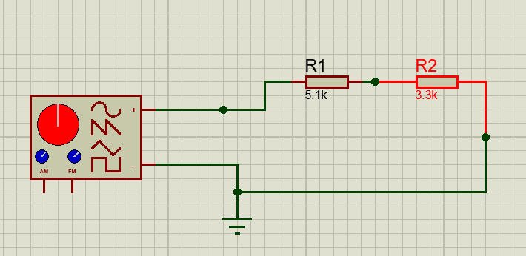
5. Then I connected the channel A of oscilloscope between input and R1, Channel B between R1 and R2 and channel C between R2 and ground.

